Week 06b: Search Tree Algorithms 2

Tree Review | 1/67
Binary search trees …
- data structures designed for O(log n) search
- consist of nodes containing item (incl. key) and two links
- can be viewed as recursive data structure (subtrees)
- have overall ordering (data(Left) < root < data(Right))
- insert new nodes as leaves (or as root), delete from anywhere
- have structure determined by insertion order (worst: O(n))
- operations: insert, delete, search, rotate, rebalance, …

Randomised BST Insertion | 2/67
Effects of order of insertion on BST shape:
- best case (for at-leaf insertion): keys inserted in pre-order
(median key first, then median of lower half, median of upper half, etc.)
- worst case: keys inserted in ascending/descending order
- average case: keys inserted in random order ⇒ O(log₂ n)
Tree ADT has no control over order that keys are supplied.
Can the algorithm itself introduce some randomness?
In the hope that this randomness helps to balance the tree …

Sidetrack: Random Numbers | 3/67
How can a computer pick a number at random?
- it cannot
Software can only produce pseudo random numbers.
- a pseudo random number is one that is predictable
  - (although it may appear unpredictable)
⇒ Implementation may deviate from expected theoretical behaviour

... Sidetrack: Random Numbers | 4/67
The most widely-used technique is called the Linear Congruential Generator (LCG)
- it uses a recurrence relation:
  - X_{n+1} = (a·X_{n} + c) mod m, where:
    - m is the "modulus"
    - a, 0 < a < m is the "multiplier"
    - c, 0 ≤ c ≤ m is the "increment"
    - X₀ is the "seed"
  - if c=0 it is called a multiplicative congruential generator
LCG is not good for applications that need extremely high-quality random numbers
- the period length is too short (length of the sequence at which point it repeats itself)
- a short period means the numbers are correlated

... Sidetrack: Random Numbers | 5/67
Trivial example:
- for simplicity assume c=0
- so the formula is X_{n+1} = a·X_{n} mod m
- try a=11=X₀, m=31, which generates the sequence:

- 11, 28, 29, 9, 6, 4, 13, 19, 23, 5, 24, 16, 21, 14, 30, 20, 3, 2, 22, 25,
- 27, 18, 12, 8, 26, 7, 15, 10, 17, 1, 11, 28, 29, 9, 6, 4, 13, 19, 23, 5,
- 24, 16, 21, 14, 30, 20, 3, 2, 22, 25, 27, 18, 12, 8, 26, 7, 15, 10, 17, 1,
- 11, 28, 29, 9, 6, 4, 13, 19, 23, 5, 24, 16, 21, 14, 30, 20, 3, 2, 22, 25, 27,
- 18, 12, 8, 26, 7, 15, 10, 17, 1, 11, 28, 29, 9, 6, 4, 13, 19, 23, 5, 24, 16,
- 21, 14, 30, 20, 3, 2, 22, 25, 27, 18, 12, 8, 26, 7, 15, 10, 17, 1, 11, 28,
- 29, 9, 6, 4, 13, 19, 23, 5, 24, 16, 21, 14, 30, 20, 3, 2, 22, 25, 27, 18,
- 12, 8, 26, 7, 15, 10, 17, 1, ...
- all the integers from 1 to 30 are here

... Sidetrack: Random Numbers | 6/67
Another trivial example:
- again let c=0
- try a=12=X₀ and m=30
  - that is, X_{n+1} = 12·X_{n} mod 30
  - which generates the sequence:

- 12, 24, 18, 6, 12, 24, 18, 6, 12, 24, 18, 6, 12, 24, 18, 6, 12, 24, 18, 6,
- 12, 24, 18, 6, 12, 24, 18, 6, 12, 24, 18, 6, ...
- notice the period length … clearly a terrible sequence

... Sidetrack: Random Numbers | 7/67
It is a complex task to pick good numbers. A bit of history:
Lewis, Goodman and Miller (1969) suggested
- X_{n+1} = 7⁵·X_{n} mod (2³¹-1)
- note:
  - 7⁵ is 16807
  - 2³¹-1 is 2147483674
  - X₀ = 0 is not a good seed value
Most compilers use LCG-based algorithms that are slightly more involved; see www.mscs.dal.ca/~selinger/random/ for details (including a short C program that produces the exact same pseudo-random numbers as gcc for any given seed value)

... Sidetrack: Random Numbers | 8/67
- Two functions are required:
srandom(int seed)
random()

where the constant RAND_MAX is defined in stdlib.h
(depends on the computer: on the CSE network, RAND_MAX = 2147483647)
- The period length of this random number generator is very large
approximately 16 · ((2³¹) - 1)

... Sidetrack: Random Numbers | 9/67
To convert the return value of random() to a number between 0 .. RANGE
- compute the remainder after division by RANGE+1
Using the remainder to compute a random number is not the best way:
- can generate a 'better' random number by using a more complex division
- but good enough for most purposes
Some applications require more sophisticated, cryptographically secure pseudo random numbers

Exercise #1: Random Numbers | 10/67
Write a program to simulate 10,000 rounds of Two-up.
- Assume a $10 bet at each round
- Compute the overall outcome and average per round

#include <stdlib.h>
#include <stdio.h>

#define RUNS 10000
#define BET 10

int main(void) {
int coin1, coin2, n, sum = 0;
for (n = 0; n < RUNS; n++) {
do {
coin1 = random() % 2;
coin2 = random() % 2;
} while (coin1 != coin2);
if (coin1==1 && coin2==1)
sum += BET;
else
sum -= BET;
}
printf("Final result: %d\n", sum);
printf("Average outcome: %f\n", (float) sum / RUNS);
return 0;
}

... Sidetrack: Random Numbers | 12/67
Seeding
There is one significant problem:
- every time you run a program with the same seed, you get exactly the same sequence of 'random' numbers (why?)
To vary the output, can give the random seeder a starting point that varies with time
- an example of such a starting point is the current time, time(NULL)
(NB: this is different from the UNIX command time, used to measure program running time)
- #include <time.h>
- time(NULL)

Randomised BST Insertion | 13/67
Approach: normally do leaf insert, randomly do root insert.
insertRandom(tree,item)
| Input tree, item
| Output tree with item randomly inserted
|
| if tree is empty then
| return new node containing item
| end if
|
| if random() mod q < p then
| return insertAtRoot(tree,item)
| else
| return insertAtLeaf(tree,item)
| end if
E.g. 30% chance ⇒ choose p=3, q=10

... Randomised BST Insertion | 14/67
Cost analysis:
- similar to cost for inserting keys in random order: O(log₂ n)
- does not rely on keys being supplied in random order
Approach can also be applied to deletion:
- standard method promotes inorder successor to root
- for the randomised method …
  - promote inorder successor from right subtree, OR
  - promote inorder predecessor from left subtree

Splay Trees

Splay Trees | 16/67
A kind of "self-balancing" tree …
Splay tree insertion modifies insertion-at-root method:
- by considering parent-child-granchild (three level analysis)
- by performing double-rotations based on p-c-g orientation
The idea: appropriate double-rotations improve tree balance.
Splay tree implementations also do rotation-in-search:
- can provide similar effect to periodic rebalance
- improves balance, but makes search more expensive

... Splay Trees | 17/67
Cases for splay tree double-rotations:
- case 1: grandchild is left-child of left-child
- case 2: grandchild is right-child of left-child
- case 3: grandchild is left-child of right-child
- case 4: grandchild is right-child of right-child
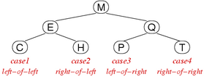

... Splay Trees | 18/67
Example: double-rotation case for left-child of left-child:
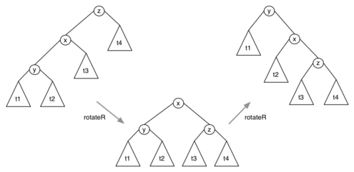

... Splay Trees | 19/67
Example: double-rotation case for right-child of left-child:
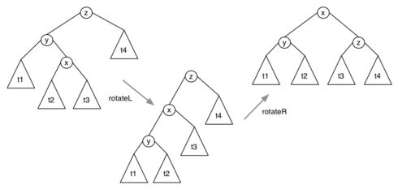

... Splay Trees | 20/67
Algorithm for splay tree insertion:
insertSplay(tree,item):
| Input tree, item
| Output tree with item splay-inserted
|
| if tree is empty then return new node containing item
| else if item=data(tree) then return tree
| else if item<data(tree) then
| | if left(tree) is empty then
| | left(tree)=new node containing item
| | else if item<data(left(tree)) then
| |
| | left(left(tree))=insertSplay(left(left(tree)),item)
| |
| | tree=rotateRight(tree)
| | else
| | right(left(tree))=insertSplay(right(left(tree)),item)
| | left(tree)=rotateLeft(left(tree))
| | end if
| | return rotateRight(tree)
| else if item>data(tree) then
| | if right(tree) is empty then
| | right(tree)=new node containing item
| | else if item<data(right(tree)) then
| |
| | left(right(tree))=insertSplay(left(right(tree)),item)
| | right(tree)=rotateRight(right(tree))
| | else
| | right(right(tree))=insertSplay(right(right(tree)),item)
| |
| | tree=rotateLeft(tree)
| | end if
| | return rotateLeft(tree)
| end if

Exercise #2: Splay Trees | 21/67
Insert 18 into this splay tree:
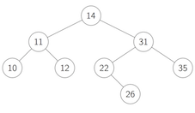

Correction:
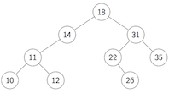

... Splay Trees | 23/67
Searching in splay trees:
searchSplay(tree,item):
| Input tree, item
| Output address of item if found in tree
| NULL otherwise
|
| if tree=NULL then
| return NULL
| else
| | tree=splay(tree,item)
| | if data(tree)=item then
| | return tree
| | else
| | return NULL
| | end if
| end if
where splay() is similar to insertSplay(),
except that it doesn't add a node … simply moves item to root if found, or nearest node if not found

Exercise #3: Splay Trees | 24/67
If we search for 22 in the splay tree

… how does this affect the tree?

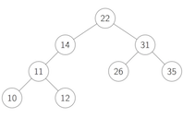

... Splay Trees | 26/67
Analysis of splay tree performance:
- assume that we "splay" for both insert and search
- consider: m insert+search operations, n nodes
- total number of comparisons: average O((n+m)·log₂(n+m))
Gives good overall (amortized) cost.
- insert cost not significantly different to insert-at-root
- search cost increases, but …
  - improves balance on each search
  - moves frequently accessed nodes closer to root
But … still has worst-case search cost O(n)

Real Balanced Trees

Better Balanced Binary Search Trees | 28/67
So far, we have seen …
- randomised trees … make poor performance unlikely
- occasional rebalance … fix balance periodically
- splay trees … reasonable amortized performance
- but both types still have O(n) worst case
Ideally, we want both average/worst case to be O(log n)
- AVL trees … fix imbalances as soon as they occur
- 2-3-4 trees … use varying-sized nodes to assist balance
- red-black trees … isomorphic to 2-3-4, but binary nodes

AVL Trees

AVL Trees | 30/67
Invented by Georgy Adelson-Velsky and Evgenii Landis
Approach:
- insertion (at leaves) may cause imbalance
- repair balance as soon as we notice imbalance
- repairs done locally, not by overall tree restructure
A tree is unbalanced when: abs(height(left)-height(right)) > 1
This can be repaired by a single rotation:
- if left subtree too deep, rotate right
- if right subtree too deep, rotate left
Problem: determining height/depth of subtrees may be expensive.

... AVL Trees | 31/67
Implementation of AVL insertion
insertAVL(tree,item):
| Input tree, item
| Output tree with item AVL-inserted
|
| if tree is empty then
| return new node containing item
| else if item=data(tree) then
| return tree
| else
| | if item<data(tree) then
| | left(tree)=insertAVL(left(tree),item)
| | else if item>data(tree) then
| | right(tree)=insertAVL(right(tree),item)
| | end if
| | if height(left(tree))-height(right(tree)) > 1 then
| | if item>data(left(tree)) then
| | left(tree)=rotateLeft(left(tree))
| | end if
| | tree=rotateRight(tree)
| | else if height(right(tree))-height(left(tree)) > 1 then
| | if item<data(right(tree)) then
| | right(tree)=rotateRight(right(tree))
| | end if
| | tree=rotateLeft(tree)
| | end if
| | return tree
| end if

Exercise #4: AVL Trees | 32/67
Insert 27 into the AVL tree


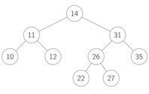

... AVL Trees | 34/67
Analysis of AVL trees:
- trees are height-balanced; subtree depths differ by +/-1
- average/worst-case search performance of O(log n)
- require extra data to be stored in each node (efficiency)
- may not be weight-balanced; subtree sizes may differ
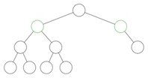

2-3-4 Trees

2-3-4 Trees | 36/67
2-3-4 trees have three kinds of nodes
- 2-nodes, with two children (same as normal BSTs)
- 3-nodes, two values and three children
- 4-nodes, three values and four children
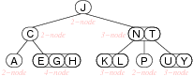

... 2-3-4 Trees | 37/67
2-3-4 trees are ordered similarly to BSTs
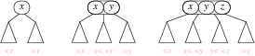
In a balanced 2-3-4 tree:
- all leaves are at same distance from the root
2-3-4 trees grow "upwards" from the leaves.

... 2-3-4 Trees | 38/67
Possible 2-3-4 tree data structure:
typedef struct node {
int order;
int data[3];
struct node *child[4];
} node;

... 2-3-4 Trees | 39/67
Searching in 2-3-4 trees:
Search(tree,item):
| Input tree, item
| Output address of item if found in 2-3-4 tree
| NULL otherwise
|
| if tree is empty then
| return NULL
| else
| | i=0
| | while i<tree.order-1 ∧ item>tree.data[i] do
| | i=i+1
| | end while
| | if item=tree.data[i] then
| | return address of tree.data[i]
| | else
| | return Search(tree.child[i],item)
| | end if
| end if

... 2-3-4 Trees | 40/67
2-3-4 tree searching cost analysis:
- as for other trees, worst case determined by height h
- 2-3-4 trees are always balanced ⇒ height is O(log n)
- worst case for height: all nodes are 2-nodes
same case as for balanced BSTs, i.e. h ≅ log₂ n
- best case for height: all nodes are 4-nodes
balanced tree with branching factor 4, i.e. h ≅ log₄ n

Insertion into 2-3-4 Trees | 41/67
Insertion algorithm:
- find leaf node where Item belongs (via search)
- if not full (i.e. order < 4)
  - insert Item in this node, order++
- if node is full (i.e. contains 3 items)
  - split into two 2-nodes as leaves
  - promote middle element to parent
  - insert item into appropriate leaf 2-node
  - if parent is a 4-node
    - continue split/promote upwards
  - if promote to root, and root is a 4-node
    - split root node and add new root

... Insertion into 2-3-4 Trees | 42/67
Insertion into a 2-node or 3-node:
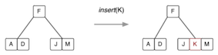
Insertion into a 4-node (requires a split):
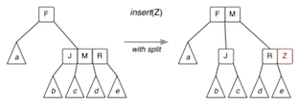

... Insertion into 2-3-4 Trees | 43/67
Splitting the root:
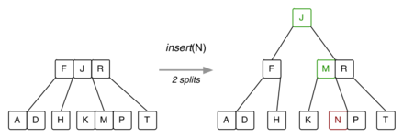

... Insertion into 2-3-4 Trees | 44/67
Building a 2-3-4 tree … 7 insertions:
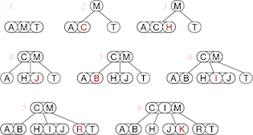

Exercise #5: Insertion into 2-3-4 Tree | 45/67
Show what happens when D, S, F, U are inserted into this tree:
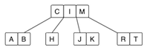

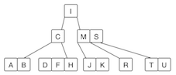

... Insertion into 2-3-4 Trees | 47/67
Insertion algorithm:
insert(tree,item):
| Input 2-3-4 tree, item
| Output tree with item inserted
|
| if tree is empty then
| return new node containing item
| end if
| node=Search(tree,item)
| parent=parent of node
| if node.order<4 then
| insert item into node
| increment node.order
| else
| | promote = node.data[1]
| | nodeL = new node containing data[0]
| | nodeR = new node containing data[2]
| | if item<node.data[1] then
| | insert(nodeL,item)
| | else
| | insert(nodeR,item)
| | end if
| | insert(parent,promote)
| | while parent.order=4 do
| | continue promote/split upwards
| | end while
| | if parent is root ∧ parent.order=4 then
| | split root, making new root
| | end if
| end if

... Insertion into 2-3-4 Trees | 48/67
Variations on 2-3-4 trees …
Variation #1: why stop at 4? why not 2-3-4-5 trees? or M-way trees?
- allow nodes to hold up to M-1 items, and at least M/2
- if each node is a disk-page, then we have a B-tree (databases)
- for B-trees, depending on Item size, M > 100/200/400
Variation #2: don't have "variable-sized" nodes
- use standard BST nodes, augmented with one extra piece of data
- implement similar strategy as 2-3-4 trees → red-black trees.

Red-Black Trees

Red-Black Trees | 50/67
Red-black trees are a representation of 2-3-4 trees using BST nodes.
- each node needs one extra value to encode link type
- but we no longer have to deal with different kinds of nodes
Link types:
- red links … combine nodes to represent 3- and 4-nodes
- black links … analogous to "ordinary" BST links (child links)
Advantages:
- standard BST search procedure works unmodified
- get benefits of 2-3-4 tree self-balancing (although deeper)

Red-Black Trees | 51/67
Definition of a red-black tree
- a BST in which each node is marked red or black
- no two red nodes appear consecutively on any path
- a red node corresponds to a 2-3-4 sibling of its parent
- a black node corresponds to a 2-3-4 child of its parent
Balanced red-black tree
- all paths from root to leaf have same number of black nodes
Insertion algorithm: avoids worst case O(n) behaviour
Search algorithm: standard BST search

... Red-Black Trees | 52/67
Representing 4-nodes in red-black trees:
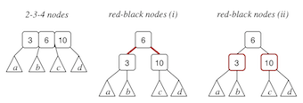
Some texts colour the links rather than the nodes.

... Red-Black Trees | 53/67
Representing 3-nodes in red-black trees (two possibilities):
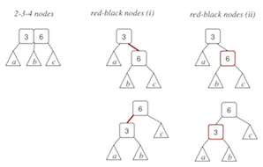

... Red-Black Trees | 54/67
Equivalent trees (one 2-3-4, one red-black):
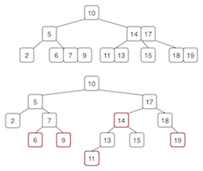

... Red-Black Trees | 55/67
Red-black tree implementation:
typedef enum {RED,BLACK} Colour;
typedef struct node *RBTree;
typedef struct node {
int data;
Colour colour;
RBTree left;
RBTree right;
} node;

#define colour(tree) ((tree)->colour)
#define isRed(tree) ((tree) != NULL && (tree)->colour == RED)
RED = node is part of the same 2-3-4 node as its parent (sibling)
BLACK = node is a child of the 2-3-4 node containing the parent

... Red-Black Trees | 56/67
New nodes are always red:
RBTree newNode(Item it) {
RBTree new = malloc(sizeof(Node));
assert(new != NULL);
data(new) = it;
colour(new) = RED;
left(new) = right(new) = NULL;
return new;
}

... Red-Black Trees | 57/67
Node.red allows us to distinguish links
- black = parent node is a "real"parent
- red = parent node is a 2-3-4 neighbour
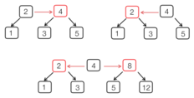

... Red-Black Trees | 58/67
Search method is standard BST search:
SearchRedBlack(tree,item):
| Input tree, item
| Output true if item found in red-black tree
| false otherwise
|
| if tree is empty then
| return false
| else if item<data(tree) then
| return SearchRedBlack(left(tree),item)
| else if item>data(tree) then
| return SearchRedBlack(right(tree),item)
| else
| return true
| end if

Red-Black Tree Insertion | 59/67
Insertion is more complex than for standard BSTs
- need to recall direction of last branch (L or R)
- need to recall whether parent link is red or black
- splitting/promoting implemented by rotateLeft/rotateRight
- several cases to consider depending on colour/direction combinations

... Red-Black Tree Insertion | 60/67
High-level description of insertion algorithm:
insertRB(tree,item,inRight):
| Input tree, item, inRight indicating direction of last branch
| Output tree with it inserted
|
| if tree is empty then
| return newNode(item)
| end if
| if left(tree) and right(tree) both are RED then
| split 4-node
| end if
| recursive insert cases (cf. regular BST)
| re-arrange links/colours after insert
| return modified tree

insertRedBlack(tree,item):
| Input red-black tree, item
| Output tree with item inserted
|
| tree=insertRB(tree,item,false)
| colour(tree)=BLACK
| return tree

... Red-Black Tree Insertion | 61/67
Splitting a 4-node, in a red-black tree:
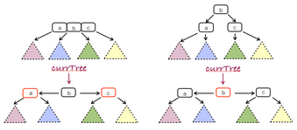
Algorithm:
if isRed(left(currentTree)) ∧ isRed(right(currentTree)) then
colour(currentTree)=RED
colour(left(currentTree))=BLACK
colour(right(currentTree))=BLACK
end if

... Red-Black Tree Insertion | 62/67
Simple recursive insert (a la BST):
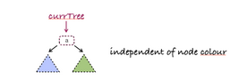
Algorithm:
if item<data(tree)) then
left(tree)=insertRB(left(tree),item,false)
re-arrange links/colours after insert
else
right(tree)=insertRB(right(tree),item,true)
re-arrange links/colours after insert
end if
Not affected by colour of tree node.

... Red-Black Tree Insertion | 63/67
Re-arrange after insert (1): two successive red links = newly-created 4-node
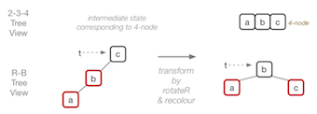
Algorithm:
if isRed(left(currentTree)) ∧ isRed(left(left(currentTree))) then
currentTree=rotateRight(currentTree)
colour(currentTree)=BLACK
colour(right(currentTree))=RED
end if

... Red-Black Tree Insertion | 64/67
Re-arrange after insert (2): "normalise" direction of successive red links
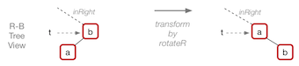
Algorithm:
if inRight ∧ isRed(currentTree) ∧ isRed(left(currentTree)) then
currentTree=rotateRight(currentTree)
end if

... Red-Black Tree Insertion | 65/67
Example of insertion, starting from empty tree:
22, 12, 8, 15, 11, 19, 43, 44, 45, 42, 41, 40, 39
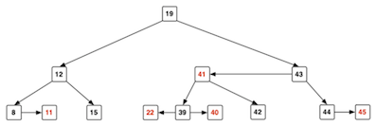

Red-black Tree Performance | 66/67
Cost analysis for red-black trees:
- tree is well-balanced; worst case search is O(log₂ n)
- insertion affects nodes down one path; max #rotations is 2·h
(where h is the height of the tree)
Only disadvantage is complexity of insertion/deletion code.
Note: red-black trees were popularised by Sedgewick.

Summary | 67/67
- Random numbers
- Self-adjusting trees
  - Splay trees
  - AVL trees
  - 2-3-4 trees
  - Red-black trees

- Suggested reading:
  - Sedgewick, Ch.13.1-13.4

Produced: 3 Jan 2018

